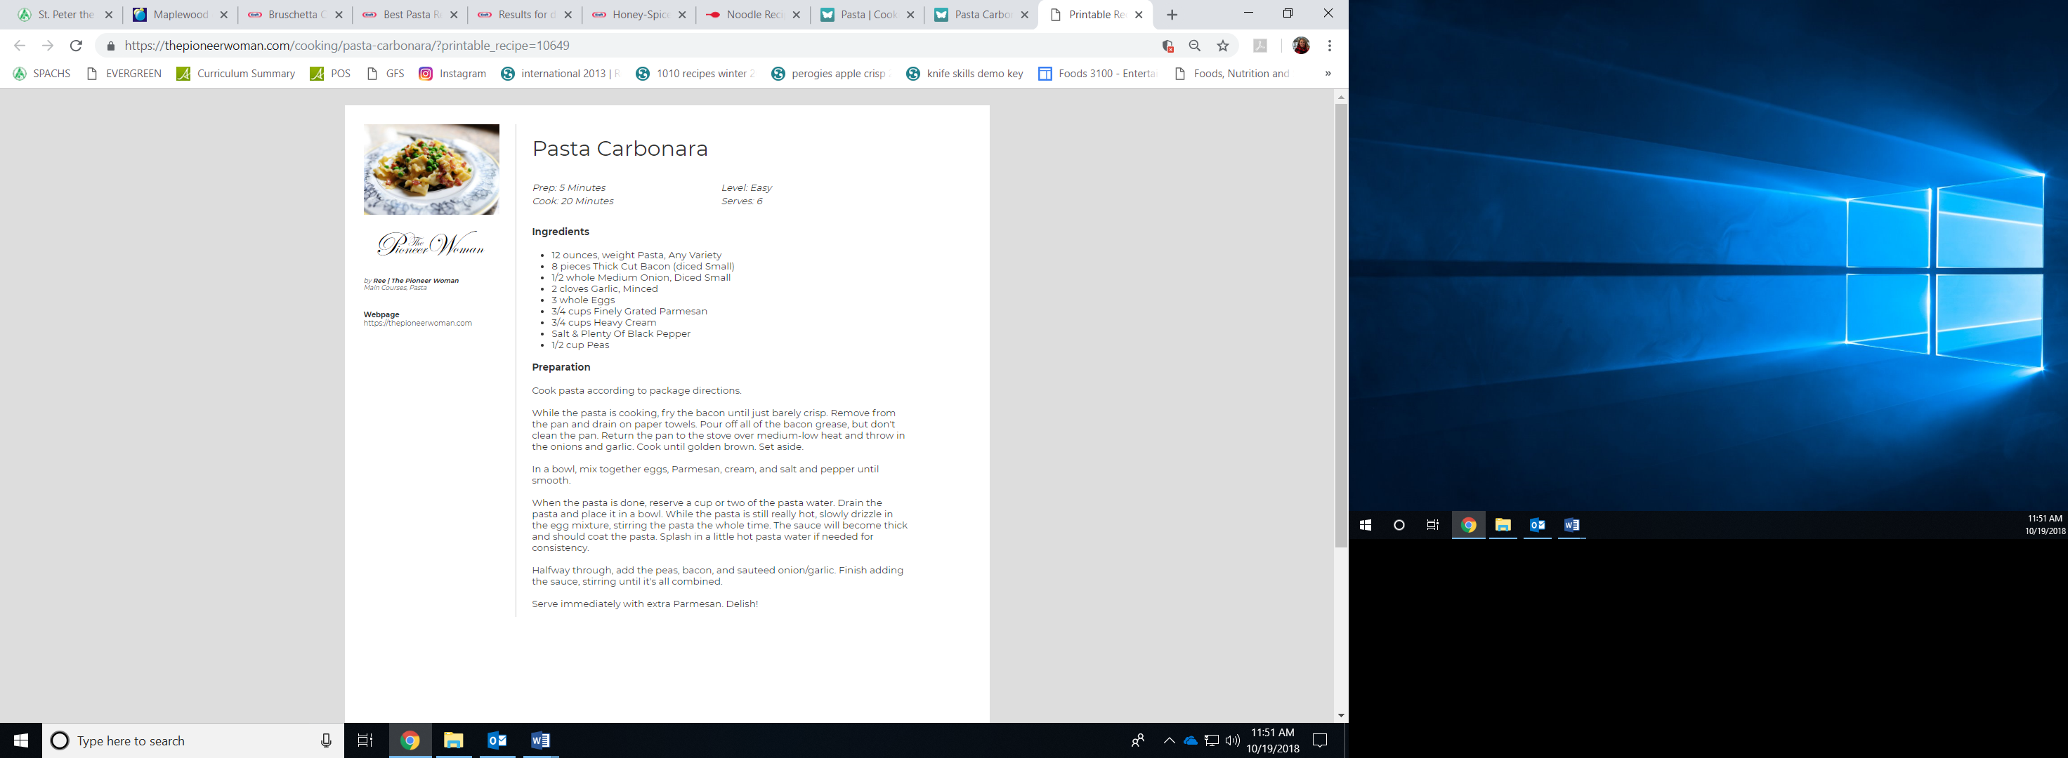

8 oz pasta, any shape

4-5 pieces bacon, diced

¼ onion, diced small

1 clove garlic, minced

2 eggs

¼ cup + 2 Tbsp grated parmesan cheese

1/3 cup whipping cream

Salt and plenty of black pepper

1/3 cup peas