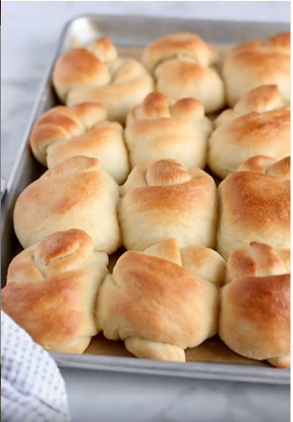
Knotted Butter Rolls

1 cup butter, melted
4 cups milk, warmed
1/2 cup sugar
3 Tablespoons yeast (active dry or instant)
6 eggs
1 Tablespoon salt
9-12 cups flour give or take
.
- In a saucepan, scald 4 cups of milk by heating it just enough that tiny bubbles appear on edge
- While the milk is heating up, cut up the butter into chunks about a tablespoon worth in size, and put them in your mixer bowl, or a large bowl if you aren’t using a mixer.
- When the milk has scalded, pour milk into the bowl with the butter which will melt the butter. Allow it to cool for a few minutes until it’s baby-bottle warm (not too hot or it will burn the yeast) then add the yeast and sugar, which will allow the yeast to dissolve and poof.
- After about 5-10 minutes you can add the salt and eggs. Mix well.
- Start adding the flour, one cup at a time, kneading well in between. Add between 10-12 cups of the flour.
The amount of flour you add will depend on many different factors, the amount of flour needed will always be a little different. When in doubt, err on the side of less flour. You want the dough to have a tacky stickiness, but not too wet/sticky.
- Knead well for 10 minutes, which will really work on the flour to develop the gluten and make it nice and stretchy.
- Cover the dough and let it rise until doubled, about 1 hour.
- Dump dough onto a slightly floured surface. Divide into 32 equal portions. Roll each portion into a 6 inch snake, then tie in a knot and set the dough knot on a baking sheet. (Of course you can form these into any shape you want.)
7. Cover dough and let rise again until doubled, or about 30-45 minutes.
8. Bake at 375°F for 16-18 minutes.
When they come out of the oven, brush with melted butter.
Enjoy!

