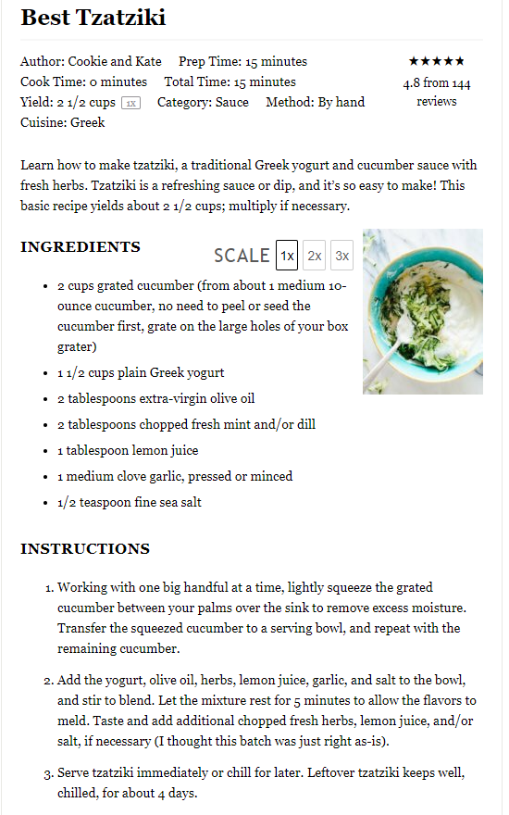

**Hummus**  
(makes about 4 cups)

**Ingredients:**

* 15 oz. chickpeas, juice from one can reserved
* 1/3 cup tahini
* 2 lemons, juice
* 3-4 cloves garlic, minced
* 1/4 tsp salt
* 1/4 tsp crushed red chili flakes
* 1/8 tsp cumin
* olive oil for drizzling
* dash paprika, for garnish

**Directions:**

1. In a blender or food processor, combine the chickpeas, tahini, lemon juice, garlic, chili flakes, salt, and cumin.
2. Gradually add in the reserved chickpea liquid, blending until smooth.
3. Add the lemon juice and blend.
4. Pour into a bowl and drizzle with olive oil and a dash of paprika.