Green Onion Cakes

Cakes
3 1/3 cup flour
2 1/2 cups boiling water (approx.)
2 Tbsp. cooking oil
2 tsp. sesame oil
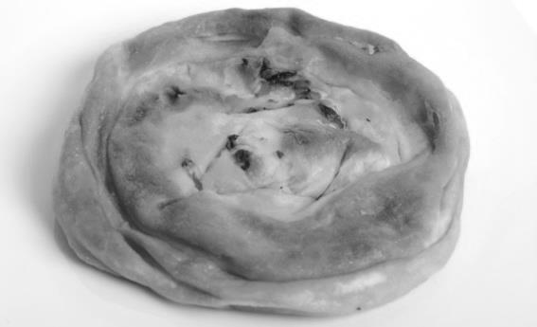
2-4 chopped green onion
2 tsp. salt
½ tsp. pepper
Cooking oil

Dipping Sauce
¼ cup chicken broth
1 tbsp. soy sauce
½ tsp. minced garlic
½ tsp. chili sauce
½ tsp. sesame oil

Getting ready:
Place flour in a bowl. Add boiling water, stirring with chopsticks or a fork until dough is evenly moistened. On a lightly flour board, knead dough until smooth and satiny, about 2 min. cover and let rest for 10min

Combine dipping sauce ingredients in a small bowl (set aside)

Make each Cake:
Roll a portion of dough into an 8-inch circle about 1/8 inch thick; keep remaining dough covered to prevent drying. Brush with a thin film of oil and sesame oil.
Then sprinkle with onions, salt and pepper.
Roll dough up into a cylinder and coil up like a snail; tuck the end of the dough underneath, you may have to press down if it gets too thick.

Cooking:
Place a wide fry pan over medium heat until hot. Add 2 tbsp oil swirling around to coat the sides. All 1 cake and cook, turning once, until golden brown. 2-3 min on each side

Remove and drain on paper towels. Repeat with remaining cakes adding more oil if needed.

