Chocolate Cake

- preheat the oven to 350’F
- lightly grease a 9x9” square cake pan, or 9” round pan.
- Using a smaller pan will increase the cooking time about 10 minutes.

Ingredients: 250 mL. boiling water
125 mL. cocoa powder

350 mL. all-purpose flour
5 mL. baking soda
1 mL. baking powder
1 mL. salt

125 mL. margarine, softened
250 mL. sugar
2 eggs
5 mL. vanilla

1. Pour boiling water over cocoa in medium bowl. Whisk until smooth. Let cool.

2. Measure flour, baking soda, baking powder and salt into another medium bowl.

3. In a large bowl cream margarine and sugar together well. Beat in eggs 1 at a time beating until light colored. Add vanilla and stir again.

4. Add the flour mixture and the cocoa mixture ALTERNATELY to the egg-sugar mixture, starting and ending with flour. [Take turns adding each.... a little bit of flour, then a little bit of cocoa; repeat until all is into the batter.]

5. Spread into prepared pan and bake in oven for 25 to 30 minutes, or until a toothpick comes out clean.

6. Allow to cool before icing.
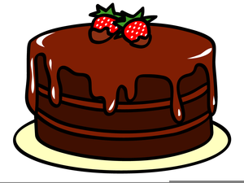
.

Creamy Chocolate Icing

Ingredients
- 1 ¼ cups confectioners' sugar
- 3 tablespoons unsweetened cocoa powder
- 3 tablespoons butter
- 2.5 tablespoons milk
- 1 teaspoon vanilla extract
- F.g (few grains) salt

Directions
- In a large bowl, cream butter until smooth,
- then gradually beat in Icing sugar, cocoa powder. And milk
- Blend in vanilla. Beat until light and fluffy. If necessary, adjust consistency with more milk or sugar.

