Buttermilk Biscuits
- 2 cups all-purpose flour
Variations
Cheddar biscuits – add ½ cup shredded cheddar
Herb Biscuits – add 1 tsp Italian Seasoning or herbs of your choice
Jalapeno Biscuits – add no more than 1/4cup chopped up jalapenos (no juice)
- 2 teaspoons baking powder
- ½ teaspoon salt
- 1/4 teaspoon baking soda
- 7 tablespoons COLD butter, cut into thin slices
- 3/4 cup cold buttermilk
- 2 tablespoons buttermilk for brushing
- Preheat oven to 425 degrees F
- Line a baking sheet with parchment paper.
- Whisk flour, baking powder, salt, and baking soda together in a large bowl.
- Cut butter into flour mixture with a pastry blender until the mixture resembles coarse crumbs. It should be LUMPY
- Make a well in the center of butter and flour mixture. Pour in 3/4 cup buttermilk; stir until just combined.
- Turn dough onto a floured work surface, pat together into a rectangle.
- Fold the rectangle in thirds. Turn dough a half turn, gather any crumbs, and flatten back into a rectangle. Repeat twice more, folding and pressing dough a total of three times.
- Roll dough on a floured surface to about 1/2 inch thick.
- Cut out 12 biscuits using a 2 1/2-inch round biscuit cutter or a glass works too
- Transfer biscuits to the prepared baking sheet. Press an indent into the top of each biscuit with your thumb.
- Brush the tops of biscuits with 2 tablespoons buttermilk.
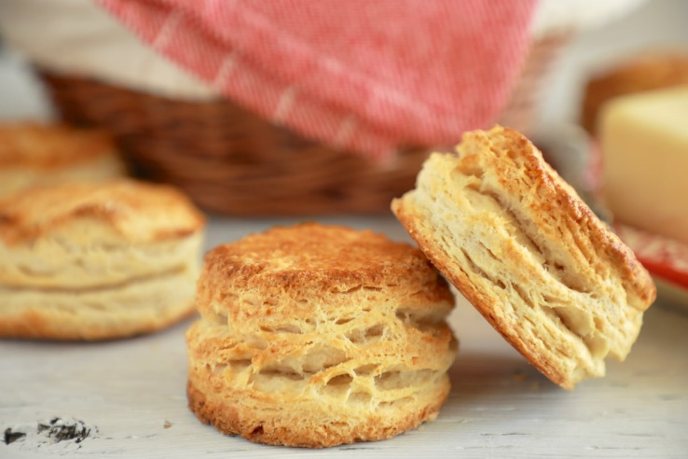
- Bake in the preheated oven until browned, about 10-15 minutes.

