**Butterhorns**

250 ml milk

125ml margarine

65 ml sugar

1 egg

pinch salt

10 ml yeast

65 ml warm water

650-800ml flour

1. In a glass measuring cup. Bloom yeast in water with only 5 ml of sugar.
2. Scald milk by putting in the microwave for about 1 min (should be hot and steaming)
3. Add margarine to the milk and stir until warm – not HOT.
4. Pour into a large bowl add the rest of the sugar (60ml) egg and salt,
5. Add in the yeast and slowly add enough flour to make a dough which is soft but not sticky
6. Let your dough rest at least 15min. punch down.
7. Let rise 1-1 ½ hours (or overnight in the refrigerator. OR place in microwave on LOW power for 1-2 min
8. Roll out dough on a dry surface,
9. Cut into long strips and twist
10. Coil and place on a parchment lined baking sheet,
11. Let rise another 30 min before baking
12. Bake @ 375F for 15 min
13. Dip in icing and ground almonds

**ICING**

15 ml margarine

250 ml icing sugar

15-45 ml milk

1-2 drops almond extract

1. Cream margarine together margarine, and icing sugar. Slowly add in the milk until the icing is medium thick.
2. Add almond extract.

[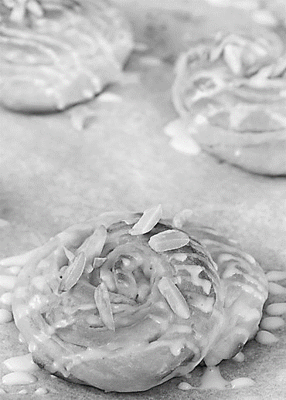](http://www.google.ca/url?sa=i&rct=j&q=&esrc=s&source=images&cd=&cad=rja&uact=8&ved=0ahUKEwj02vGy6M_MAhUY3GMKHYFjA4UQjRwIBw&url=http%3A%2F%2Fredstaryeast.com%2Fheavenly-butterhorns%2F&psig=AFQjCNEBxgyywsyKre_IaM1Sqn0g108W2w&ust=1462980282382418)