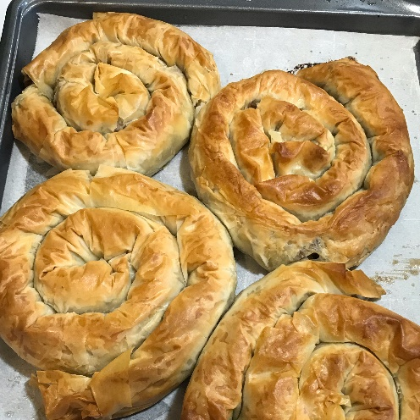
Traditional Rolled Burek (Borek)
Borek or burek is a filled pastry made of a thin flaky dough such as filo with a variety of fillings, such as meat, cheese, spinach or potatoes.
Boreks are mainly associated with the areas, including the
Balkans (Albania, Bulgaria, Romania and Greece and the former Yugoslavia)
Middle East (Cyprus, Jordan, Lebanon, Israel, Palestine, Syria, Iraq and Turkey),
https://www.thespruceeats.com/traditional-yugoslavian-rolled-burek-borek-recipe-1805900

• 1 tablespoon olive oil
• 1 medium yellow onion (peeled and chopped)
• 1 pound ground beef
• 1 teaspoon allspice
• 2 teaspoons paprika
• 1 teaspoon garlic powder
• 1 teaspoon onion powder
• 2 tablespoons chopped parsley
• salt & black pepper
• 1 Tablespoon Worcestershire sauce
• 1 box phyllo pastry (sheet, 12 inches x 17 inches)
• 1/2cup butter (melted)
1. Gather the ingredients.
2. Heat a large frying pan over medium heat and add the oil.
3. Sauté the onion until soft, and then add the ground beef, allspice, paprika, garlic powder, onion powder salt, and pepper to taste. Add Worcestershire sauce.
4. Cook until the meat is crumbly but not dry.
Sprinkle in the parsley at the very end.
Cool completely before you continue. While ground beef mixture is cooling, preheat oven to 375 F.

5. Once cooled, lay one sheet of phyllo dough on the counter. Keep the remaining sheets of phyllo dough covered with a damp kitchen towel, and work quickly to prevent it from drying out.

6. Brush sheet with some of the melted butter. Place a heaping 1/3 cup of meat mixture on the sheet along the long side, 2 inches from the edge.

7. Fold the bottom over the meat mixture and roll into a snake shape. Roll into a snail shape.

8. Place rolled dough and ground beef pinwheel on a nonstick baking sheet and butt the end up against the edge of the pan to prevent uncoiling. Brush with additional butter. Continue until you've used all the ground beef.

9. Bake in a preheated oven 15 to 20 minutes or until just golden.

