1-HOUR SOFT AND BUTTERY DINNER ROLLS
- 1 cup water
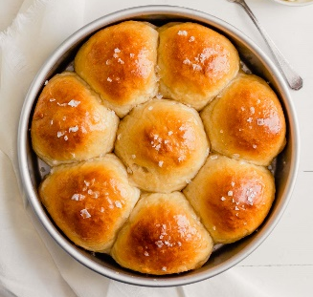
- 2 tablespoons melted butter
- 1/2 cup milk
- 2 tablespoons honey
- 1 tablespoon active-dry yeast*
- 3 1/2 to 4 cups all-purpose flour
- 1 teaspoon salt
- extra melted butter, for brushing on top
- Prep your oven and baking dish. Heat the oven to 400°F. Grease a 9 x 13-inch baking dish with cooking spray, and set aside.
- Heat the liquids. In a microwave-safe bowl (or saucepan,)stir together the water and melted butter, then add in the milk and honey and stir until combined. Microwave the mixture for 1 minute and give it a stir. Continue microwaving the mixture in 15 second intervals, until it reaches 110°F. It will be warm but not hot to the touch.
- Add yeast. Pour the liquid mixture into the large bowl of a stand mixer. Sprinkle the yeast evenly on top, give it a quick stir with a fork to combine, and let the yeast activate for 5 minutes until it is foamy.
- Add dry ingredients. Add in 3 1/2 cups of flour (NOT all of the flour) and the salt.
- Mix. Use the dough-hook to mix in the dry ingredients on medium-low speed until combined. If the dough is sticking to the sides of the bowl, add in 1/4 cup more flour at a time until the dough pulls away from the sides of the bowl and is only slightly sticky to the touch. (Only use up to 4 cups of flour total.) Continue mixing on low speed for 4-5 minutes until the dough is smooth. Then form the dough into a ball with your hands and transfer it to a greased bowl.
- Let the dough rise. Cover the bowl with a damp towel or paper towel, and let it rise briefly for 15 minutes.
- Form the rolls. Gently punch the dough down and divide into 14-15 equal-sized pieces. Form each piece into a ball and place the dough balls in the greased baking dish. Cover the dish again with a damp towel or paper towel and let the dough balls rise for an additional 15-20 minutes.

- Bake. Uncover and bake for 15 minutes, or until the rolls are lightly golden brown on top and cooked through

- Serve warm. Then serve warm and enjoy!

